PHYS 201 Fall 2016 SFQ on Equilibrium Name:______________________________

1. In an isometric exercise a person places a hand on a scale and pushes vertically downward, keeping the forearm horizontal. This is possible because the triceps muscle applies an upward force perpendicular to the arm, as the drawing indicates. The forearm weighs 25.0 N and has a center of gravity as indicated. The scale registers 115 N. Determine the magnitude of
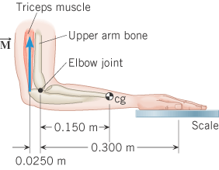

2. A man holds a 148-N ball in his hand, with the forearm horizontal (see the drawing). He can support the ball in this position because of the flexor muscle force M, which is applied perpendicular to the forearm. The forearm weighs 21.0 N and has a center of gravity as indicated. What is the magnitude of M?
